Easyplan
The easy way to plan your retirement

A Brief Summary
- Easyplan is simple to open and operate.
- You can start, stop or change contribution levels to suit your circumstances.
- You’re fully informed via quarterly statements, annual reports, and access to ATMs, Fastphone and the ASB BANK Customer Service Centre.
- Your returns are not assessable for the National Superannuation surcharge.
- Optional ASB BANK Term Life and Recovery Care Insurance can be arranged.
Easyplan is made available by the ASB BANK Retirement Savings Scheme - a registered superannuation scheme in terms of the Superannuation Schemes Act 1989.
The Scheme is a Trust established by ASB BANK. The trustee is ASB Superannuation Nominees Ltd, a subsidiary of ASB BANK Limited.
Important Note: The ASB BANK Retirement Savings Scheme, through Easyplan, provides a market linked investment where members participate in the earnings of the scheme. Returns are not guaranteed by ASB BANK Limited and can fluctuate up or down from one period to the next. Returns can be negative and this could mean you receive back less than your own contributions.

The Retirement Savings Plan That’s Better All Round
Fact: New Zealanders are living longer
Fact: The number of working people supporting each New Zealand Superannuitant is expected to halve over the next 40 years.
Fact: Successive governments have made it clear we cannot expect substantial state pensions in the years to come.
Conclusion: It has never been more vital that you make your own provisions for your retirement.

The good news is that ASB BANK has introduced Easyplan - an altogether fairer retirement savings plan.

Easyplan is fairer because you’re not charged high fees - no entry or start-up fees and no sales commissions. A 1% per annum management fee is deducted from your contributions.



No Sales Commissions
Unlike many superannuation schemes, Easyplan does not divert part of your retirement savings into the pockets of commission salespeople. With Easyplan you’ll also find there are no entry or administration fees - a 1% annual management fee is deducted from your contributions.

Easyplan is also flexible - allowing you to make regular contributions, lump sum contributions, or a combination of both.

Easyplan combines everything you should be looking for in a retirement savings scheme - competitive returns, flexibility and convenience.

Lump sum option: | $1,000 initial contribution
Additional lump sums: | $200
Regular option: | $50 per month minimum  (no maximum)
It is recommended that contributions are inflation linked.

Introducing The Three Easyplan Funds
Depending on your preferences, your Easyplan savings can be invested in any or all of the three Funds each of which maintain completely separate assets.

For each Fund, a ‘benchmark’ has been established which specifies the normal percentage of each type of assets that will make up the Fund. These proportions have been determined to produce the greatest expected long term returns for investors, consistent with the various risk levels required by the Trustee.

If the Investment Managers consider that certain financial markets will perform better or worse than expected, they can vary the percentage of each asset type, but only within the range permitted by the Trustee. There are other constraints placed on the Investment Managers to ensure, eg too high a proportion of the assets is not invested in a particular company or country.



The following three pie charts show the benchmark allocations for each of the Funds, together with the upper and lower ranges for each investment sector.

1 The Managed Fund
Catering for investors looking for a balanced investment strategy, this Fund consists of a mix of shares, property, fixed interest securities and interest-bearing deposits, both within New Zealand and overseas. Because the value of these investments may fluctuate from time to time, this Fund is recommended only for longer term investors.

Benchmark Proportions
The following pie shows:
Range:
Overseas Equities (10-30%)
Property (0-20%)
Cash (5-40%)
NZ Fixed Interest (10-50%
Overseas Fixed Interest (0-25%)
NZ Equities (20-40%)

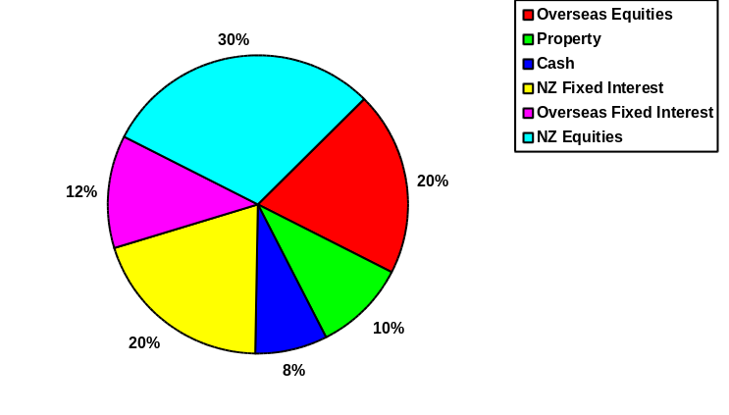

2 The Cash Enhanced Fund
The Cash Enhanced Fund invests mainly in short term securities issued by the Government, SOE’s, major public companies and registered banks. The investments include long term securities with ten or more years to maturity. This Fund is suitable for investors requiring a more cautious investment strategy.

Benchmark Proportions
Range:
NZ Fixed Interest (0-30%)
Cash (50-100%)

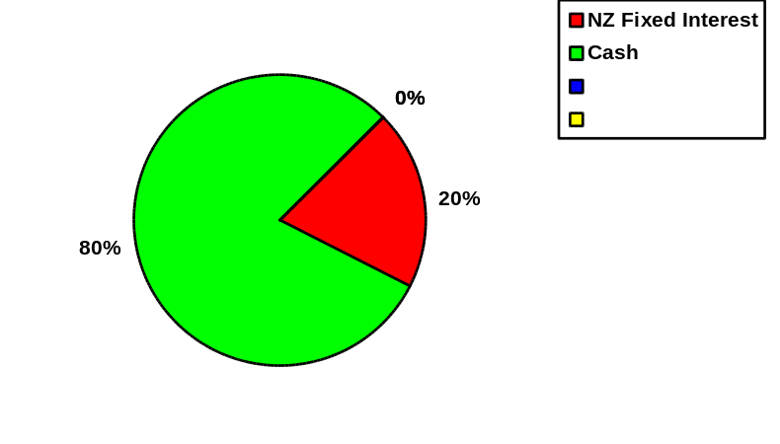

3 The Capital Stable Fund
This Fund follows a conservative strategy, investing mainly in fixed interest securities plus some equity investments. High grade fixed interest bonds issued by international governments and major companies are also included together with small proportions of New Zealand and overseas shares. These improve the prospects for better long term returns and provide a more diversified portfolio of investments to minimise risk even further.

Benchmark Proportions
Range:
Overseas Equities (0-10%)
Cash (10-60%)
NZ Fixed Interest (30-80%)
Overseas Fixed Interest (0-20%)
NZ Equities (0-20%)

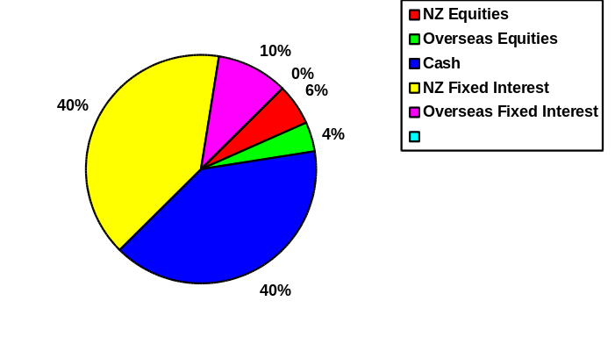

ASB BANK Easyplan - The Key Points

- Managed Fund
- Capital Stable Fund
- Cash Enhanced Fund
- All returns to investors are tax-paid and are not currently assessable for the National Superannuation surcharge.

If you would like to open an ASB BANK Easyplan Retirement Savings Scheme, simply fill out the attached application form and questionnaire, then take the forms into your local ASB BANK branch - our staff will help you get started.

To find out more about ASB BANK Easyplan and how it could make your retirement years so much brighter, phone us on our toll-free number 0800-803-804 or, simply call in to any ASB BANK branch. ASB BANK staff are more than happy to answer any questions you may have.



